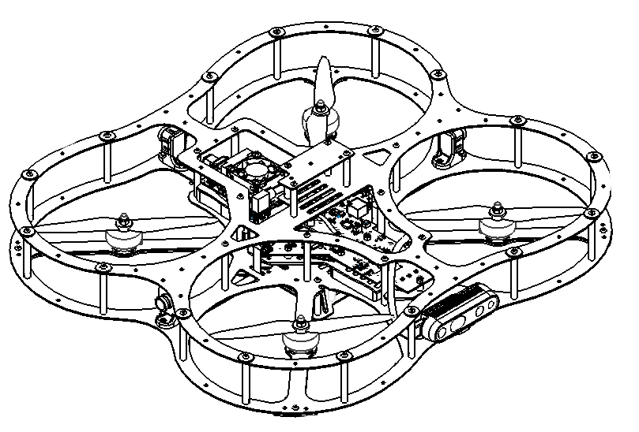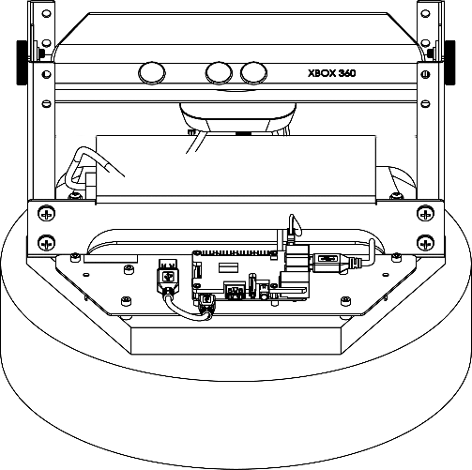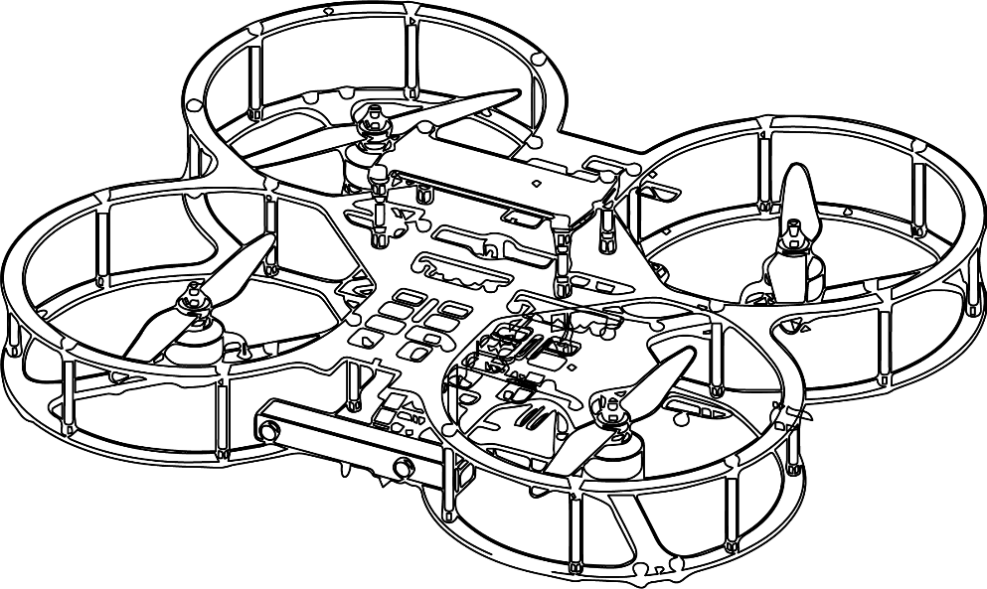

**Autonomous Vehicles Research Studio**

Setup Guide – Communication Infrastructure

© 2023 Quanser Inc., All rights reserved

For more information on the solutions Quanser Inc. offers,   
please visit the web site at: <http://www.quanser.com>

|  |  |
| --- | --- |
| Quanser Inc.  119 Spy Court  Markham, Ontario  L3R 5H6, Canada | info@quanser.com  Phone : 19059403575  Fax : 19059403576  printed in Markham, Ontario. |

This document and the software described in it are provided subject to a license agreement. Neither the software nor this document may be used or copied except as specified under the terms of that license agreement. Quanser Inc. grants the following rights: a) The right to reproduce the work, to incorporate the work into one or more collections, and to reproduce the work as incorporated in the collections, b) to create and reproduce adaptations provided reasonable steps are taken to clearly identify the changes that were made to the original work, c) to distribute and publicly perform the work including as incorporated in collections, and d) to distribute and publicly perform adaptations. The above rights may be exercised in all media and formats whether now known or hereafter devised. These rights are granted subject to and limited by the following restrictions: a) You may not exercise any of the rights granted to You in above in any manner that is primarily intended for or directed toward commercial advantage or private monetary compensation, and b) You must keep intact all copyright notices for the Work and provide the name Quanser Inc. for attribution. These restrictions may not be waved without express prior written permission of Quanser Inc.

**FCC Notice** This device complies with Part 15 of the FCC rules. Operation is subject to the following two conditions: (1) this device may not cause harmful interference, and (2) this device must accept any interference received, including interference that may cause undesired operation.

**Industry Canada Notice** This Class A digital apparatus complies with Canadian ICES-003. Cet appareil numérique de la classe A est conforme à la norme NMB-003 du Canada.

**Waste Electrical and Electronic Equipment (WEEE)**

This symbol indicates that waste products must be disposed of separately from municipal household waste, according to Directive 2002/96/EC of the European Parliament and the Council on waste electrical and electronic equipment (WEEE). All products at the end of their life cycle must be sent to a WEEE collection and recycling center. Proper WEEE disposal reduces the environmental impact and the risk to human health due to potentially hazardous substances used in such equipment. Your cooperation in proper WEEE disposal will contribute to the effective usage of natural resources.

|  |  |
| --- | --- |
|  | This product meets the essential requirements of applicable European Directives as follows:   * 2006/95/EC; Low-Voltage Directive (safety) * 2004/108/EC; Electromagnetic Compatibility Directive (EMC)   **Warning**: This is a Class A product. In a domestic environment this product may cause radio interference, in which case the user may be required to take adequate measures. |
| caution.png **Caution** | **This equipment is designed to be used for educational and research purposes and is not intended for use by the public.** The user is responsible to ensure that the equipment will be used by technically qualified personnel only. While the end-effector board provides connections for external user devices, users are responsible for certifying any modifications or additions they make to the default configuration. |

Table of Contents

A. Communication Infrastructure 3

B. Checkpoint – Basic TCP/IP demo 4

# A. Communication Infrastructure

The ground control station PC is connected to the router via an ethernet cable (wired connection). The QBot 2 connects to the router over 2.4GHz wifi (SSID: Quanser_UVS). The QDrones 1/2 and QBot 2e connect to the router over the 5GHz wifi (SSID: Quanser_UVS-5G). This is illustrated in Figure 1 below.

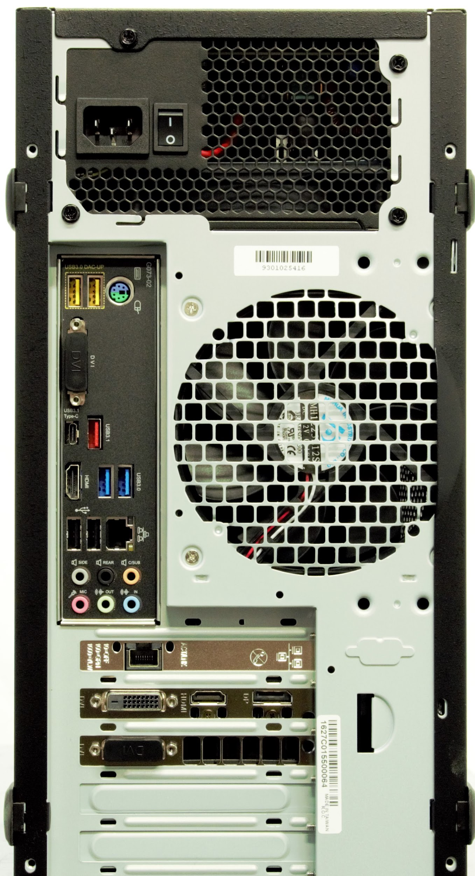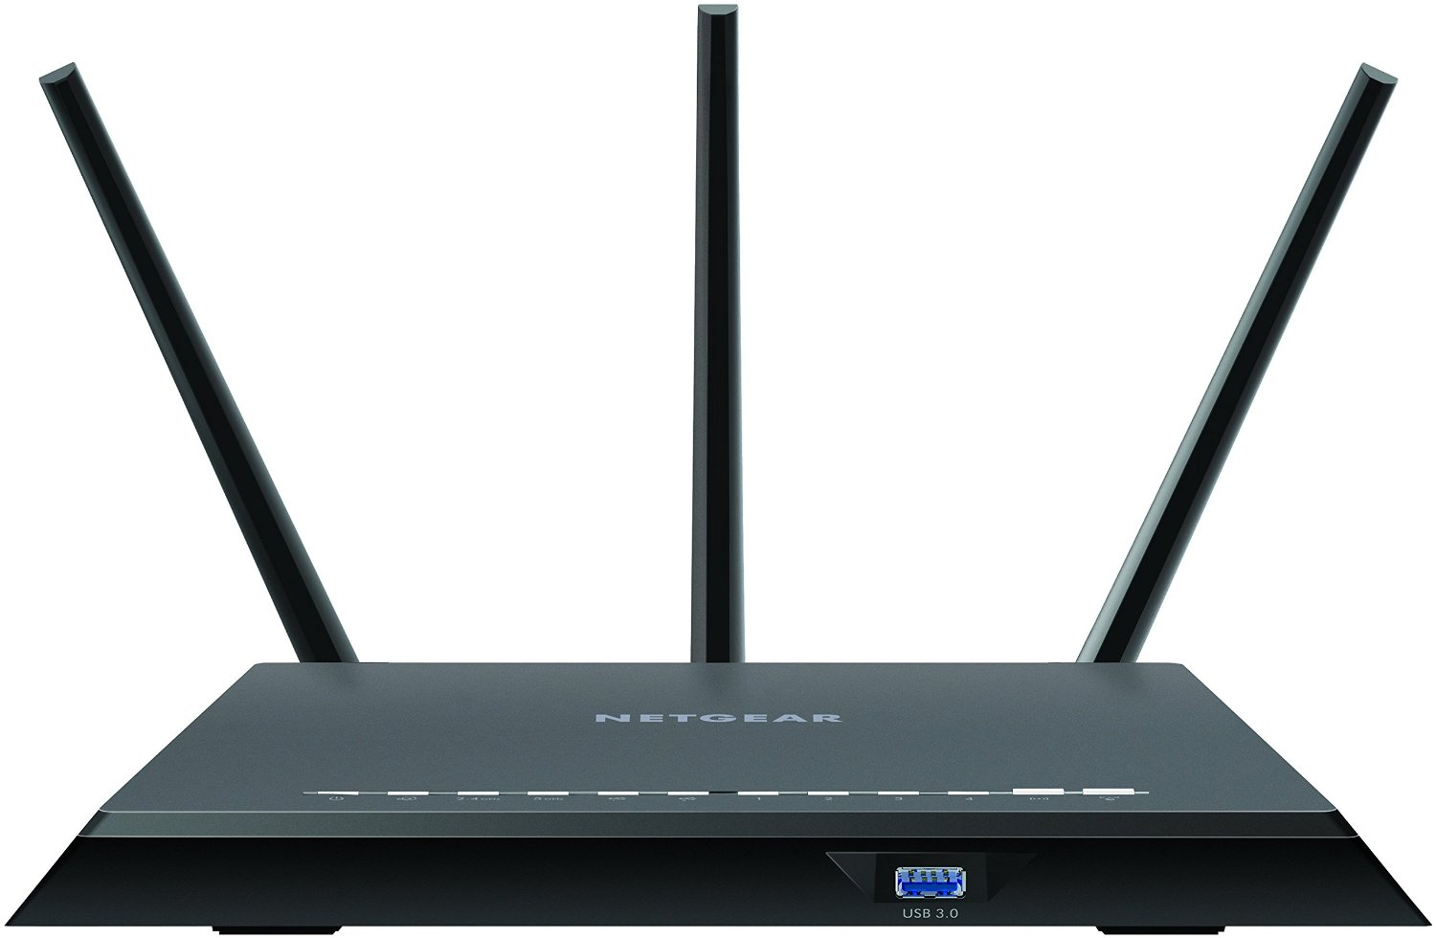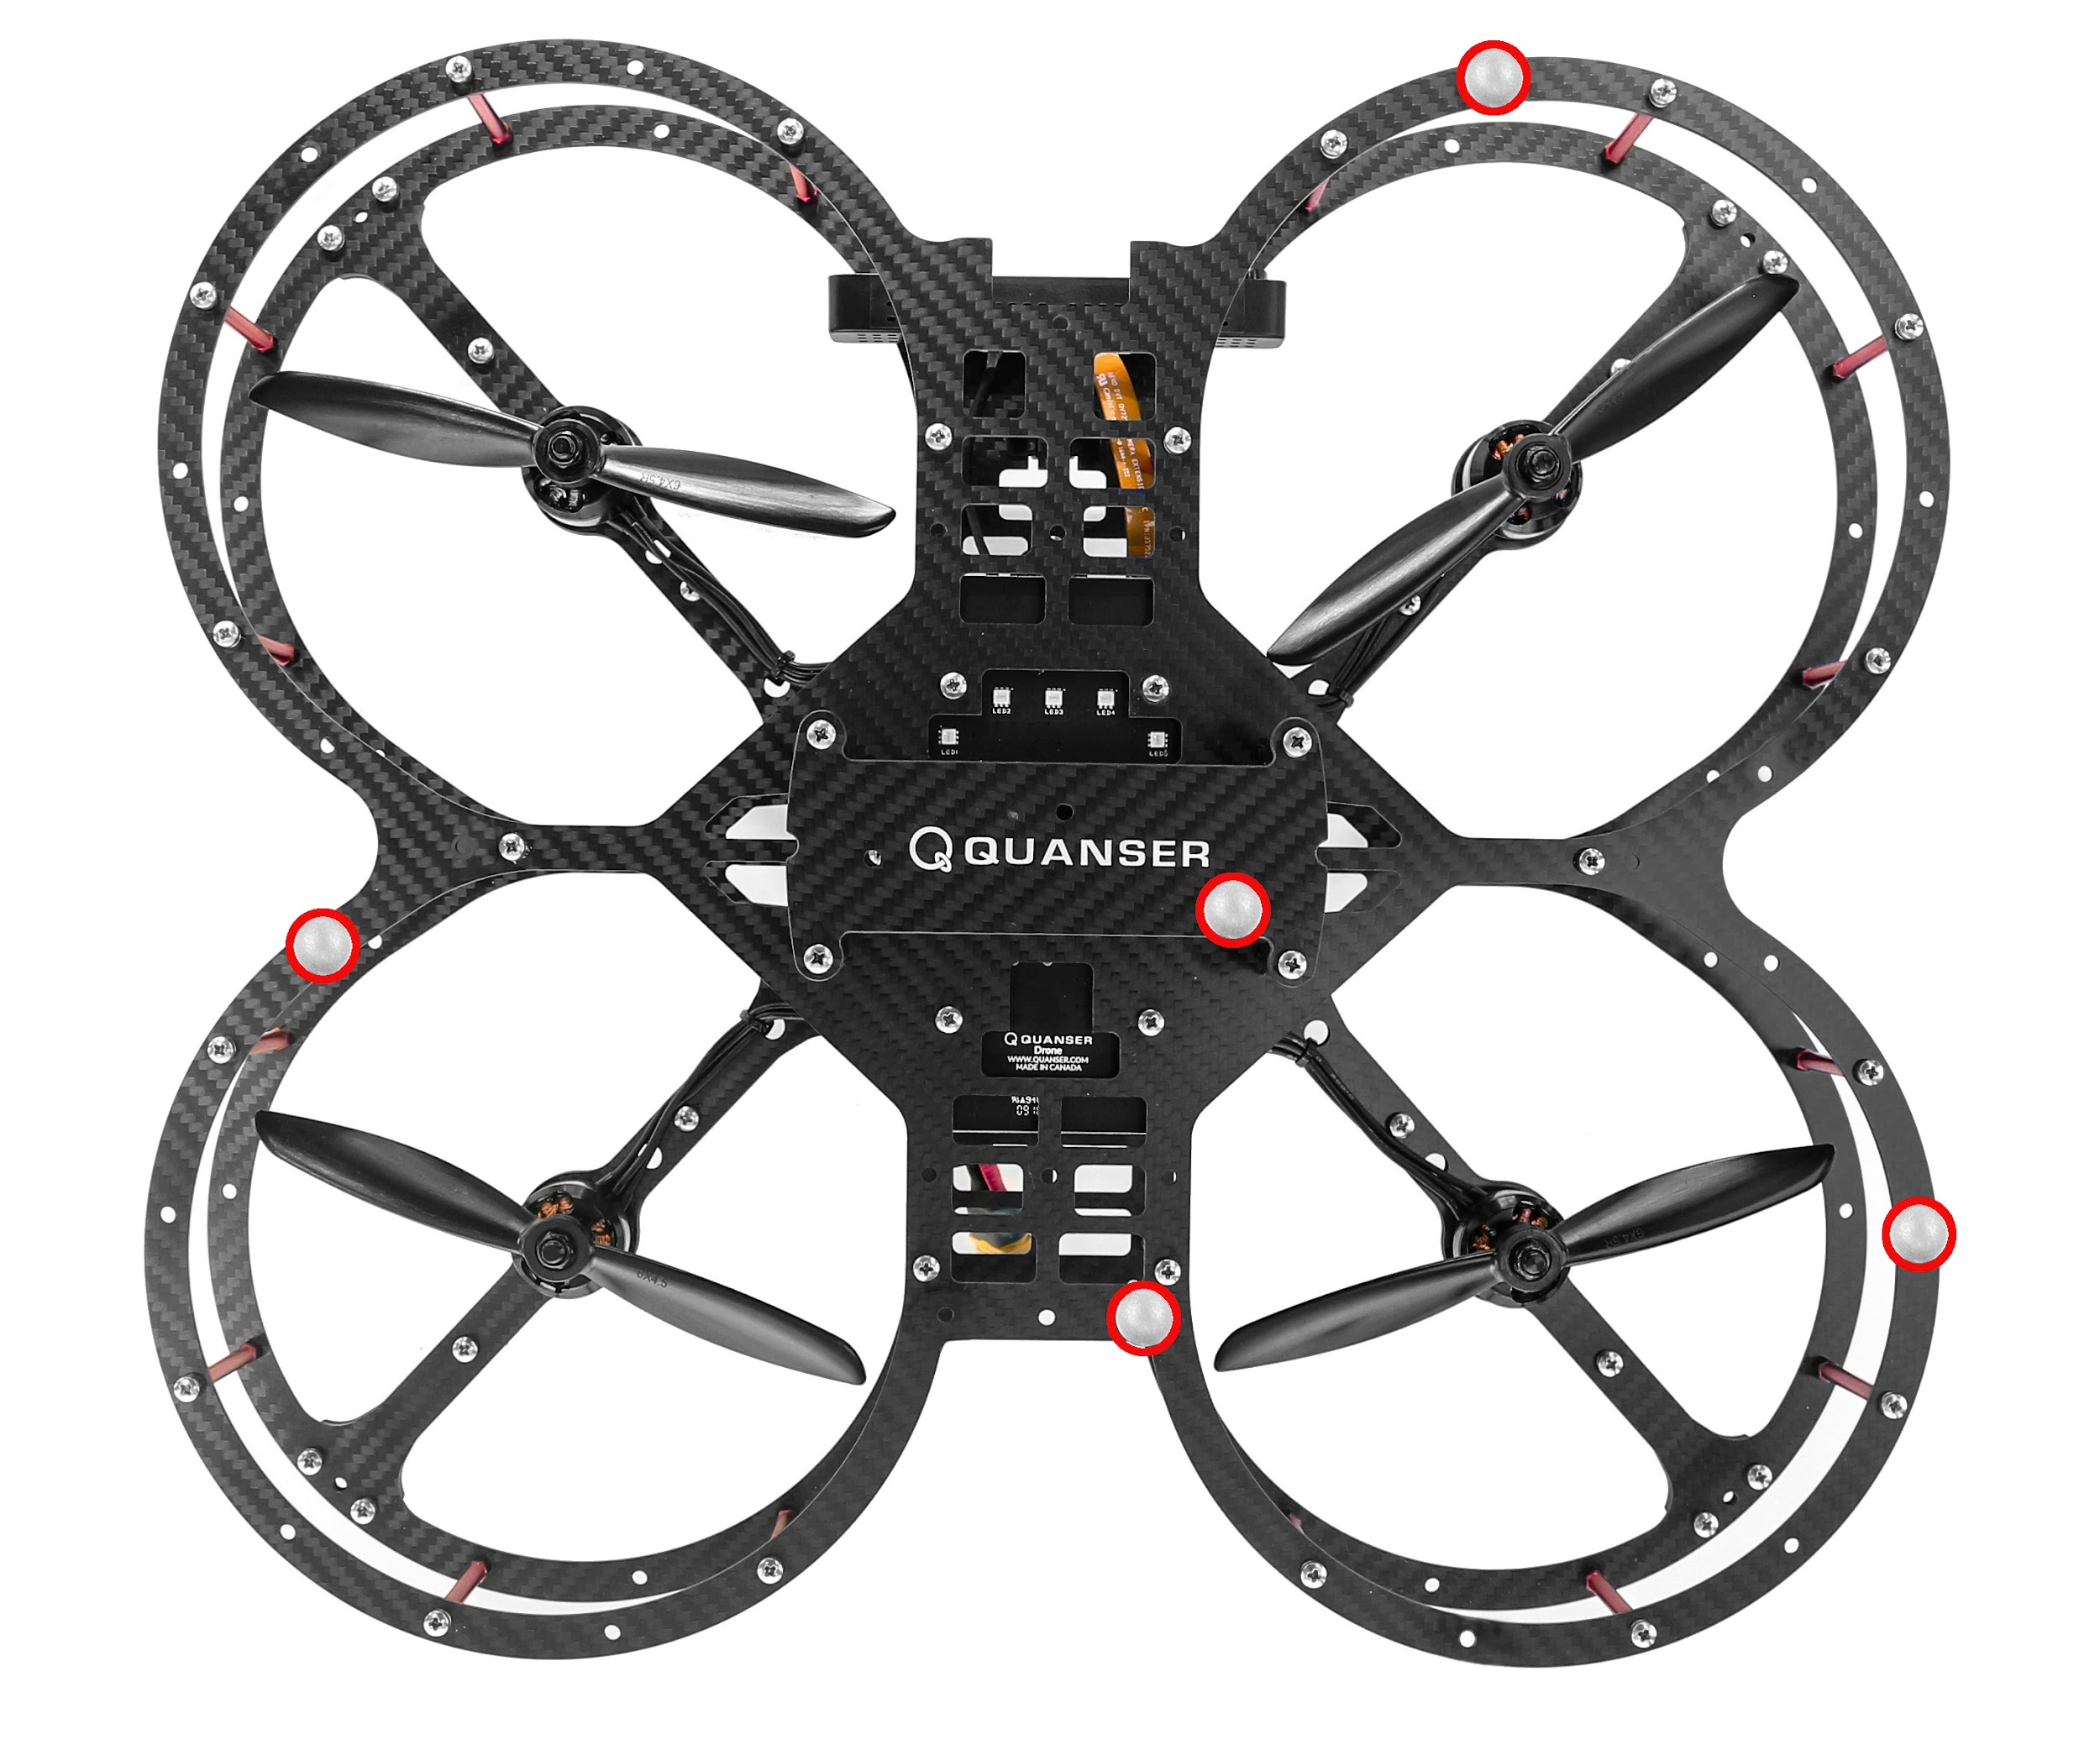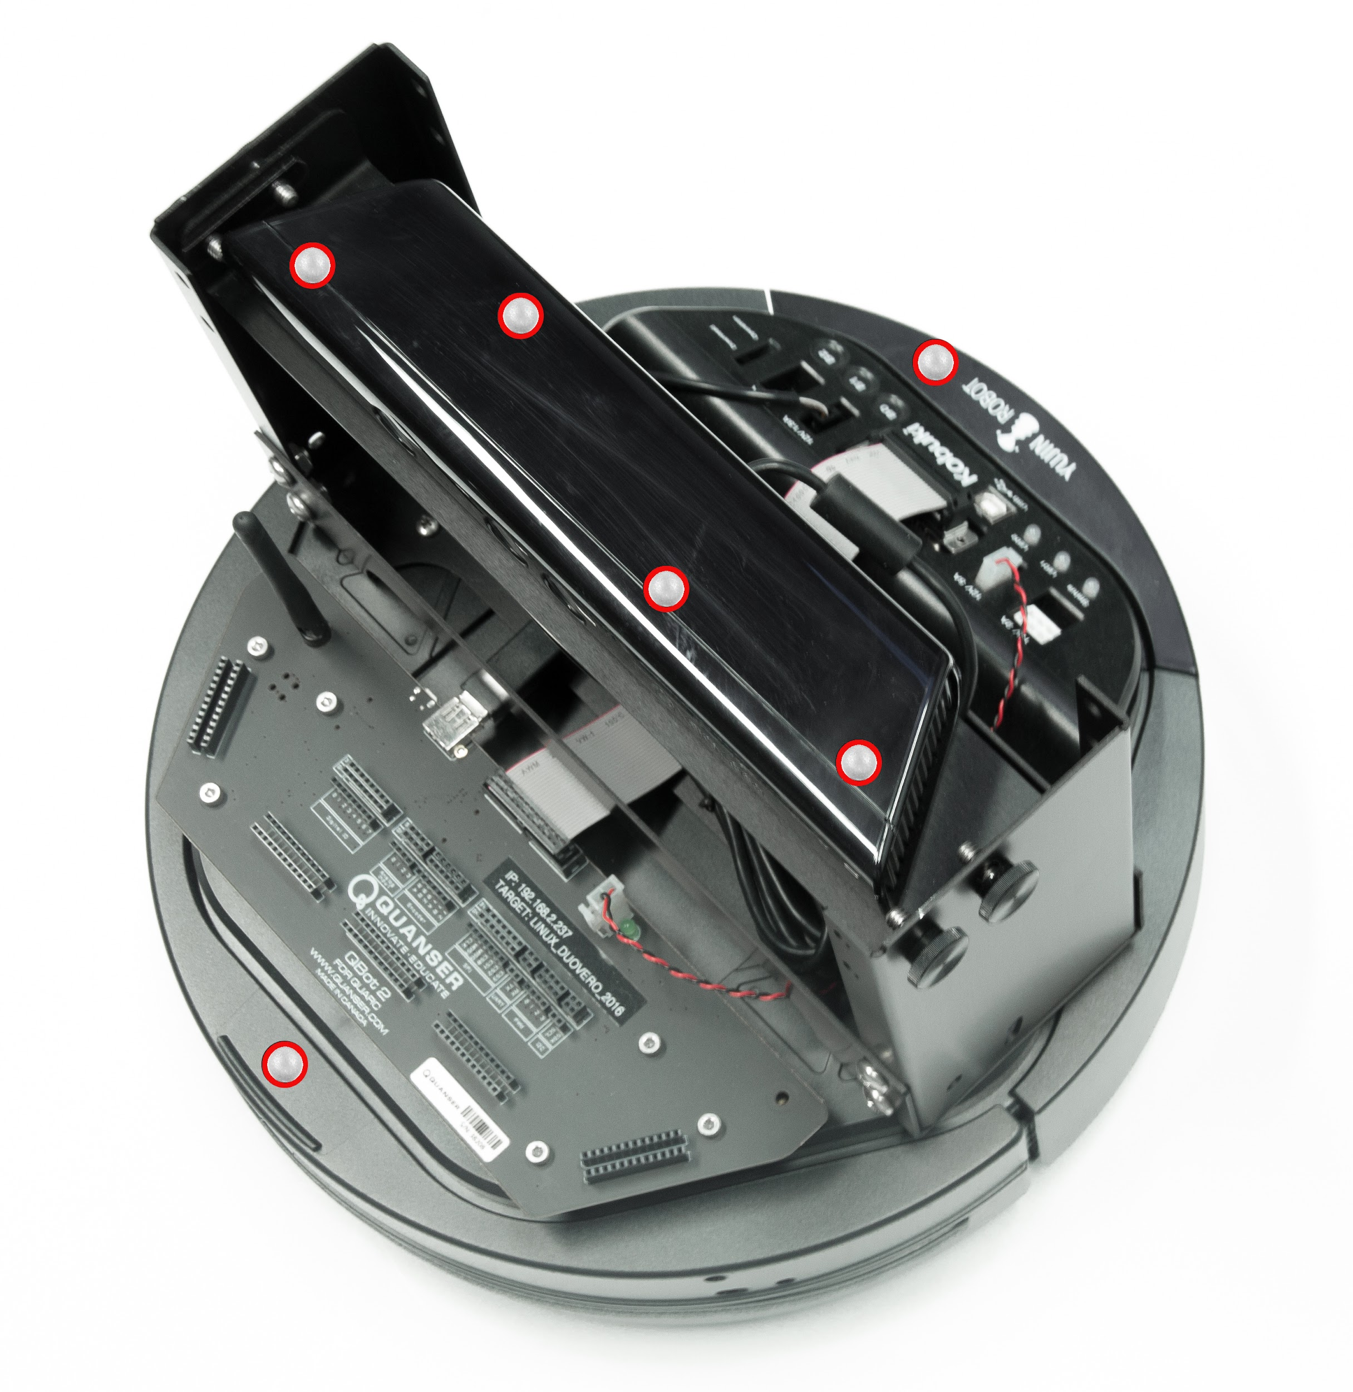

**Wired Ethernet Connection**

**5 GHz Wi-Fi: Quanser_UVS-5G**

**2.4 GHz Wi-Fi: Quanser_UVS**

**Router**

**Ground Station PC**

**Qdrone 1/2 / QBot 2e**

**QBot 2**

Figure 1. Communication Infrastructure

# B. Checkpoint – Basic TCP/IP demo

|  |  |  |  |  |  |  |  |  |  |  |  |  |  |  |  |  |  |  |  |  |
| --- | --- | --- | --- | --- | --- | --- | --- | --- | --- | --- | --- | --- | --- | --- | --- | --- | --- | --- | --- | --- |
| 1. After reading the Communications file for the product you have (product_communication.docx), turn the vehicle on. 2. In your **MATLAB Command Window**, type  >> qc_show_demos 3. In the **QUARC Examples Help** page, scroll down and click on the QUARC Basic Communications Demo under **Communications**. 4. Click on **Open these Models** on the top right of the page, which opens two Simulink/QUARC models. 5. In the quarc_basic_client_demo model that loads, from the **HARDWARE** tab on top of your Simulink model, click on **Hardware Settings** (Gear Icon). (If using an older version, click on **Model Configuration Properties** under the **Simulation** drop menu.) 6. In this window, click on **Code Generation** on the left side of the window, click on **Browse** next to the **System target file** (Figure 2a) and select the appropriate target for your vehicle (Figure 2b).  |  |  | | --- | --- | |  |  | | a. System target file. | b. QUARC targets for each product. | | Figure 2: Setting target on models. | |  1. Expand **Code Generation** on the left side of the window, click on interface and set the **MEX-file arguments** (Figure 3) as follows:   **If using a QDrone 1:** '-w -d %d -uri %u','tcpip://QDrone0xxxxx.local:17001'  where QDrone0xxxxx refers to the hostname of the QDrone 1 you are using (found below the battery compartment plate).  **If using a QBot or QDrone 2:** '-w -d %d -uri %u','tcpip://192.168.2.d:17001'  Where 192.168.2.d refers to the IP of the vehicle you are using.  Press OK. The window should close.   |  | | --- | |  | | Figure 3: Setting the MEX-file arguments under Model Configuration Properties for the desired vehicle. |  1. In the same Simulink model, double click the Stream Client block, and change the URI of host to which to connect to (Figure 4):   tcpip://192.168.2.5:18000  Note that the IP 192.168.2.5 must be changed if you set the ground control station IP to another address. See the Router to PC Connection in the setup documents.   |  | | --- | |  | | Figure 4: Setting the IP of the host in the Stream Client block. |  1. On both the **quarc_basic_server_demo** and **quarc_basic_client_demo** click on the **HARDWARE** tab on the top menu, and then click the green play button (**Monitor & Tune**), It should build and start the model.   **Note**: In case a model does not download (MATLAB Command Window returns a ‘Failed to download …’ error), you can try to manually **Deploy** it from the **QUARC** tab.   1. The **Received Data** and **Sent Data** scopes in both models should display data as shown in Figure 5 below. The Server sends a sine wave (Figure 5a), and the Client receives this (Figure 5c). The Client sends a sawtooth wave (Figure 5b), and the Server receives this (Figure 5d).  |  |  | | --- | --- | |  |  | | a. Server Sent Data (sent from PC) | b. Client Sent Data (sent from vehicle) | |  |  | | c. Client Received Data (received on vehicle) | d. Server Received Data (received on PC) | | Figure 5: Sent and Received Data scopes in the Basic TCP/IP Communications Demo | |  1. Stop both the models. |

This completes the checkpoint task and confirms that your communication infrastructure is set up correctly. If you encounter any errors, make sure that all the steps prior to this checkpoint have been followed. If further issues persist, please contact Quanser technical support (tech@quanser.com).

© Quanser Inc., All rights reserved.

Solutions for teaching and research. Made in Canada.